

Project report in DAT255 – Deep Learning Engineering

Multi-Label Classification of Chest X-Ray Pathologies Using Convolutional Neural Networks and Transfer Learning

30.04.2026
Hans Christian Gustafsson (candidate number 678277)
Jonatan Dam (candidate number 678278)
Magne Svalland (candidate number 678287)
Github repo:
https://github.com/MagneSvalland/chexpert-disease-detection
Web application:
https://huggingface.co/spaces/Magnen/chexpert-disease-detection
Contents
Project report in DAT255 – Deep Learning Engineering 1
Table of figures 3
Table of tables 3
1 Problem description 4
2 Data 5
2.1 Data source 5
2.2 Data description 5
2.3 Exploratory data analysis 6
2.4 Data challenges 8
2.5 Data preprocessing 9
3 Model implementation 9
3.1 Overview of model choices 9
3.2 Theoretical motivation 9
3.3 Baseline CNN architecture 10
3.4 Transfer learning architecture 11
4 Evaluation 12
4.1 Results 12
4.1.1 Baseline performance 12
4.1.2 Transfer learning performance 15
4.1.3 Summary comparison 17
4.2 Comparison with existing solutions 18
4.3 Interpretation techniques 18
4.4 Model utilization and limitations 20
5 Deployment 20
6 Conclusion 21
References 22
Appendix: Declaration of use of Artificial Intelligence 24

Table of figures
Figure 1: Sample chest X-ray images from dataset 6
Figure 2: Label distribution in the dataset 7
Figure 3: Distribution of uncertain labels 7
Figure 4: Distribution of missing values 8
Figure 5: Baseline CNN-model architecture 11
Figure 6: DenseNet121 architecture 12
Figure 7: AUC and loss over epochs for CNN 13
Figure 8: Baseline CNN AUC per condition 13
Figure 9: Precision, Recall and F1-score in baseline CNN 14
Figure 10: F1-score in default vs. optimal threshold in baseline CNN 14
Figure 11: AUC and loss over epochs for DenseNet121 15
Figure 12: DenseNet121 AUC per condition 16
Figure 13: Precision, Recall and F1-score in DenseNet121 16
Figure 14: F1-score in default vs. optimal threshold in DensetNet121 17
Figure 15: AUC per condition comparison 18
Figure 16: Grad-CAM Heatmap of Correctly Predicted Pleural Effusion 19
Figure 17: Grad-CAM Heatmap for Edema 19

Table of tables
Table 1: Summary of performance metrics 17

1 Problem description
Chest radiography is one of the most widely used imaging modalities in modern medicine and plays a central role in the diagnosis of thoracic diseases. It is typically the first imaging examination used for patients presenting with symptoms such as chest pain, shortness of breath or persistent cough [1]. Due to its low cost, speed, and non-invasive nature, some countries report chest X-ray imaging accounting for up to 20% of diagnostic imaging done [2].
Chest radiographs provide valuable information about the lungs, heart, and surrounding structures, which enables clinicians to detect a wide range of conditions, including pneumonia, lung cancer, oedemas and lesions.
Despite its importance, the interpretation of chest radiographs remains a challenging task. Klein and Rosado-de-Christenson explains that this is because of “The superimposition of complex structures of various radiographic density (gas, water, calcium, metal and fat)” [1]. The nature of this superimposition, projecting three-dimensional anatomical structures onto a two-dimensional image, and the subtle nature of many pathological findings makes this one of the most difficult radiographs to interpret [3]. This can make chest radiography interpretation a time-consuming task in a sector that does not usually have a surplus of time to perform tasks.
Given these challenges, there is a growing need for automated systems that can assist clinicians in interpreting these images. There already exist traditional machine learning methods for disease classification in medical image analysis, which rely on handcrafted features by experts [4]. In contrast, deep learning approaches such as convolutional neural networks can automatically learn feature representations directly from raw image data, enabling them to detect subtle patterns that may not be easily visible to the experts crafting handcrafted features [5]. Due to this, deep learning models typically outperform classic machine learning models based on handcrafted features, due to learned features being extracted automatically to solve a specific task [6].
There already exist some deep learning solutions for diagnosing pathologies from chest radiographs. One such solution is CheXNet, a 121-layer convolutional neural network that outputs the probability of pneumonia based on a chest X-ray image as input [7]. A common weakness in deep learning solutions is a limited insight into the reasoning behind their predictions. In a medical context, results from these solutions will be interpreted by medical personnel who may not be proficient with technology, and thus this “black box” prediction can reduce trust in the validity of the result.
The aim for this project is therefore not only to develop a deep learning model for chest X-ray classification, but also to extend existing approaches by incorporating interpretability techniques. Methods such as Grad-CAM will be used to highlight image regions that contribute to model predictions, providing visual explanations that can support clinicians in understanding and validating the model’s output.
To evaluate the success of the project, several quantitative metrics will be used. Since the task involves multi-label classification, performance will primarily be assessed using AUROC (Area Under the Receiver Operating Characteristic Curve) for each class, as well as the mean AUROC across all classes. AUROC is particularly suitable for imbalanced datasets, as it evaluates the model’s ability to rank positive instances higher than negative ones independent of a fixed classification threshold. In addition, metrics such as precision, recall, and F1-score will be evaluated to provide a comprehensive evaluation of model performance.
There is no mathematical formula for interpretability, and due to its subjective nature, it will be difficult to provide an accurate metric for interpretability within the scope of this project. With more time and resources, we would ideally develop our model and allow health personnel to test it and give us feedback through a survey and semi-structured qualitative interviews. However, this task would be too large for the scope of this project, and thus we will instead show Grad-CAM heatmaps and compare correct predictions to incorrect predictions to assess whether the model focuses on clinically relevant regions.

2 Data

2.1 Data source
This project uses a version of the CheXpert dataset, a large-scale dataset for automated chest radiograph interpretation, called “CheXPert-v1.0-small” from the Kaggle user “ashery” [8]. The dataset consists of approximately 224,000 chest X-ray images collected from clinical practice and annotated for the presence of 14 different conditions.

2.2 Data description
The dataset is divided into predefined training and validation sets, where each row in the corresponding CSV- files represents a single radiograph and its associated labels. The labels are encoded as follows: a value of 1 indicates that a condition is present, 0 indicates that it is absent, -1 indicates uncertainty, and missing values (NaN) indicate that the condition was not mentioned in the report.
The 14 conditions included in the dataset are: No Finding, Enlarged Cardiomediastinum, Cardiomegaly, Lung Opacity, Lung Lesion, Edema, Consolidation, Pneumonia, Atelectasis, Pneumothorax, Pleural Effusion, Pleural Other, Fracture and Support Devices. It is important to note that “Support Devices” does not represent a disease, but rather the presence of medical equipment visible in the radiograph.
Visual inspection of sample images show that the dataset consists of grayscale chest radiographs. The images include both frontal and lateral views.
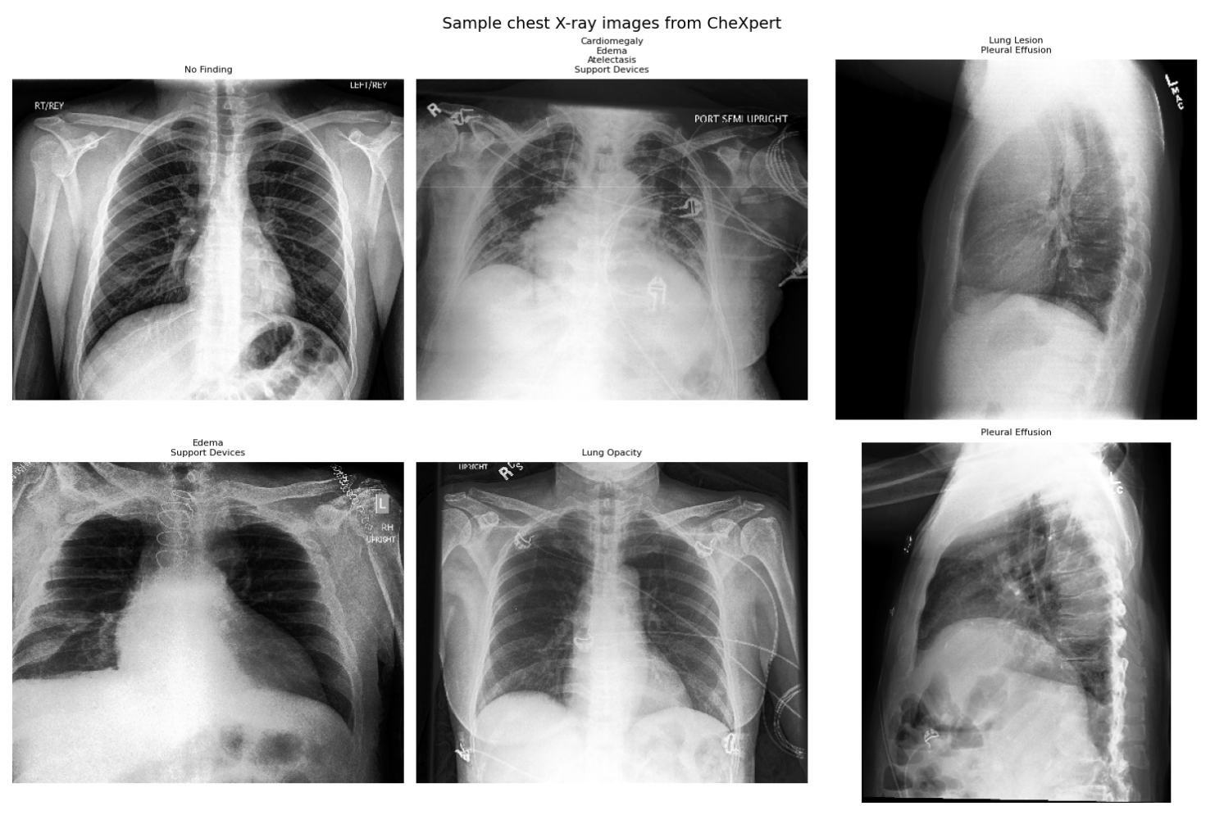
Figure 1: Sample chest X-ray images from dataset

2.3 Exploratory data analysis
A key observation from the analysis is the significant class imbalance present in the dataset. Some conditions, such as Pleural Effusion and Atelectasis, occur frequently, while others such as Fracture and Lung Lesion, are relatively rare. This imbalance can negatively impact model performance, as models may become biased towards more frequent classes.
In addition to class imbalance, the dataset contains a substantial number of uncertain labels. The number of uncertain labels varies across conditions, indicating that some pathologies are inherently more difficult to diagnose from chest radiographs. Furthermore, missing values are present.
Figure 2, Figure 3 and Figure 4 shows us label distribution, as well as the distribution of uncertain- and missing values.
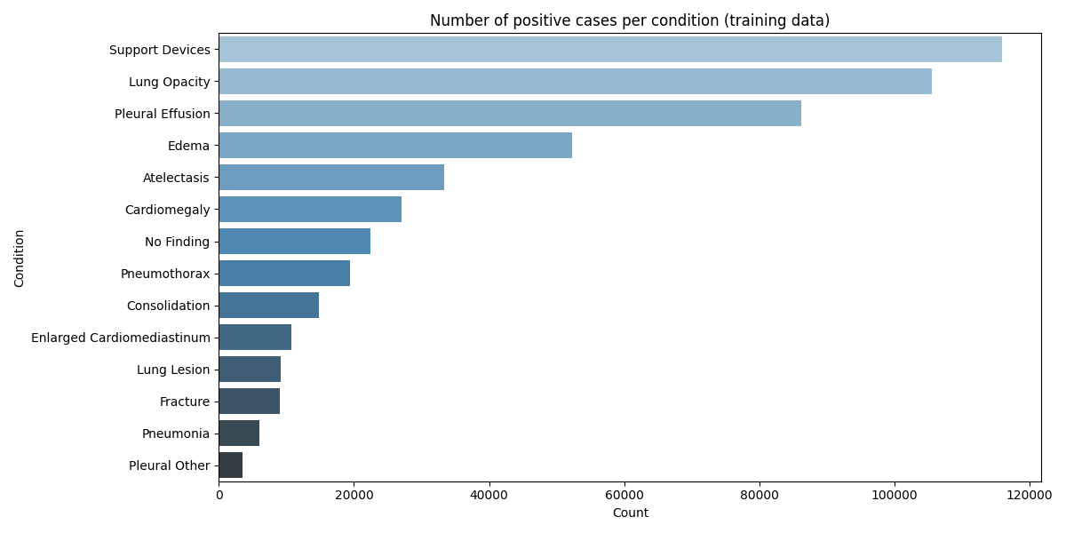
Figure 2: Label distribution in the dataset

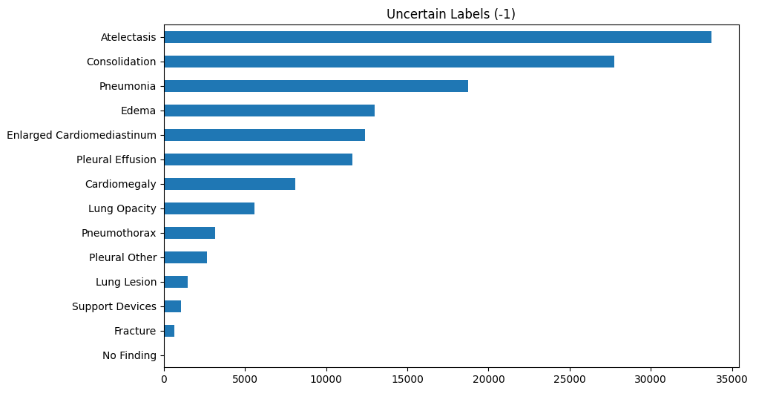
Figure 3: Distribution of uncertain labels

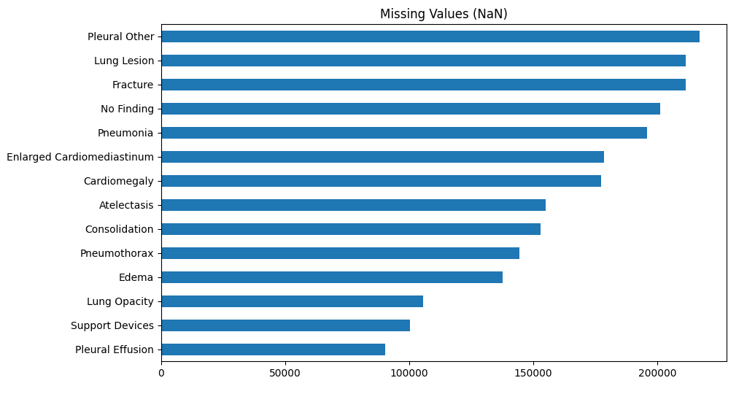
Figure 4: Distribution of missing values

2.4 Data challenges
This dataset presents several challenges that must be addressed in order to train a reliable deep learning model. A primary challenge is the significant class imbalance observed across the 14 conditions. EDA revealed that certain pathologies, such as Pleural Effusion and Edema, are relatively common, whereas other conditions such as Fracture and Lung Lesion are less common. This imbalance can bias the model toward predicting the majority classes, which could potentially lead to poor performance on rare but clinically important conditions.
Another important challenge is the presence of uncertain labels and missing values for some labels. These labels arise from ambiguity in the original radiology reports, and reflect the difficulty of diagnosing certain conditions from chest radiographs. The proportion of missing- and uncertain labels varies between classes, further complicating the learning process. If these labels are not handled appropriately, they can introduce noise and negatively affect model performance.
The dataset is also heterogeneous in image characteristics, with variations in image quality, contrast, and contains both frontal and lateral chest radiographs. These variations increase the complexity of the classification task and requires the model to generalize across diverse inputs.

2.5 Data preprocessing
We focus on the 5 clinically most important conditions selected by Stanford for the CheXpert competition, Atelectasis, Cardiomegaly, Consolidation, Edema and Pleural Effusion [9]. For handling uncertain- and missing labels, label preprocessing was performed. In this project, uncertain labels were treated as negative for the baseline model, except for the pathologies Atelectasis and Edema. These two pathologies were treated as positives, as this is in line with the Stanford Baseline [9]. This approach simplifies the multi-label classification problem and allows the use of standard loss functions. Missing values were also replaced with 0, based on the assumption that unmentioned conditions are likely not present.
Then image paths were corrected to match the directory structure of the dataset as downloaded in Kaggle. The original paths contained a prefix which did not correspond to the folder structure, and this prefix was removed programmatically.
Image data was then standardized through resizing and normalization. All images were read and decoded as a JPEG image with three channels, resized to a resolution of 224x224 pixels to ensure consistency in the input dimensions for the neural network, and normalized to the range [0, 1].

3 Model implementation

3.1 Overview of model choices
In this project, two different deep learning approaches were implemented and compared for multi-label classification of chest radiographs:
- A baseline convolutional neural network (CNN) trained from scratch
- A transfer learning model based on DenseNet121
These models were chosen to represent two fundamentally different strategies: learning features directly from the dataset versus leveraging pre-trained representations. This enables a meaningful comparison between a simple baseline and a more advanced architecture.

3.2 Theoretical motivation
CNNs are well-suited for image analysis tasks due to their ability to learn feature representations. Early convolutional layers capture low-level features such as edges and textures, while deeper layers learn more abstract patterns relevant for classification.
The baseline CNN serves as a reference model, allowing evaluation of how well a relatively simple architecture can learn from the CheXpert dataset.
The second approach uses DenseNet121, a densely connected convolutional network in which each layer receives feature maps from all preceding layers. This design improves gradient flow and promotes feature reuse. These properties are beneficial in medical imaging tasks, where detecting subtle patterns are important. DenseNet121 was selected also because it is used in the original CheXpert study by Irvin et al., enabling direct comparison with established baselines [9].

3.3 Baseline CNN architecture
The baseline CNN was implemented from scratch using Keras and TensorFlow. Following the CheXpert benchmark, the model was designed to perform multi-label classification on chest radiographs for the five previously chosen conditions [9].
The architecture consists of four convolutional blocks; each composed of a convolutional layer followed by max pooling. The number of filters increases progressively (32, 64, 128, 256), enabling the model to learn increasingly complex spatial features. All convolutional layers use a 3x3 kernel, ReLU activation, and same padding.
After feature extraction, a global average pooling layer is applied to reduce the spatial dimensions, followed by a fully connected classification head. The head consists of a dense layer with 256 units and ReLU activation, with dropout layers (0.5 and 0.3) applied for regularization. The final output layer uses a sigmoid activation function to produce independent probabilities for each of the five conditions, reflecting the multi-label nature of the task.
Due to its adaptive learning rate, the Adam optimizer was used with a learning rate of 0.0001, in the hopes that this would lead to a faster convergence compared to standard stochastic gradient descent. Since this is a multi-label classification problem, binary cross-entropy was used as the loss function. To improve training stability and prevent overfitting, several callbacks were used, including early stopping based on validation AUC, model checkpointing to save the best performing model, and adaptive learning rate reduction when validation performance plateaued.

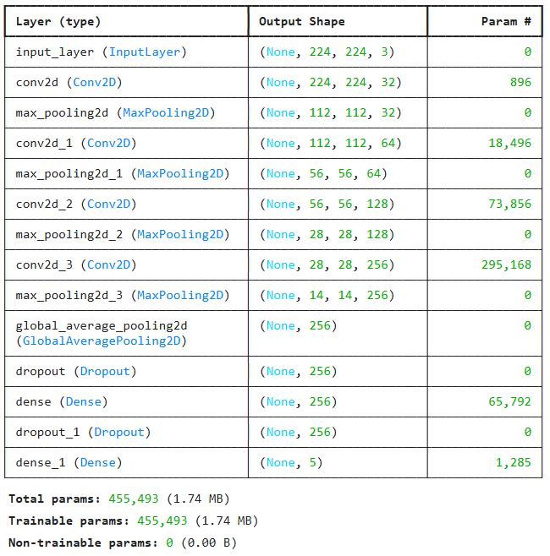
Figure 5: Baseline CNN-model architecture

3.4 Transfer learning architecture
In an attempt to improve performance, a second model based on transfer learning was implemented using DenseNet121. This architecture was chosen specifically because it is the architecture used in the original CheXpert paper, which allows us to compare our results directly against their baseline [9]. The transfer learning approach follows a two-phase training strategy, as covered by Chollet & Watson in chapter 8 of Deep Learning with Python [10]. The first phase consists of first freezing the convolutional base to prevent their weights of being updated during training, and then adding a classification head to be trained. Initially, only the top 50 layers of the base model were unfrozen, which produced suboptimal results. We therefore chose to unfreeze all layers and jointly fine-tune the entire network with a very low learning rate of 1e-5. This slightly adjusts all learned representations to better fit our medical imaging task, while the low learning rate prevents destroying the pre-trained ImageNet weights.
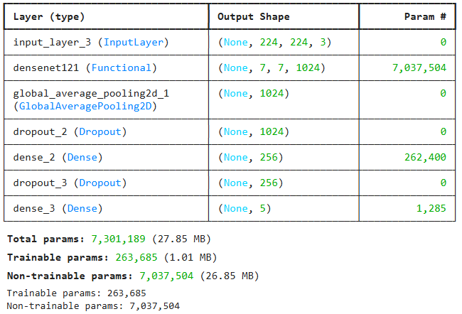
Figure 6: DenseNet121 architecture

4 Evaluation

4.1 Results

4.1.1 Baseline performance
To establish a reference point, the performance of the baseline CNN was evaluated on the validation set. Plotting AUROC and loss for training and validation gives us Figure 7.
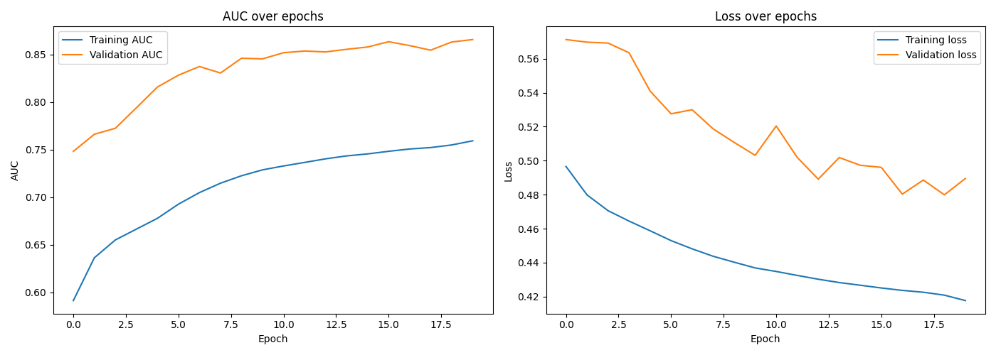
Figure 7: AUC and loss over epochs for CNN

The model achieved a mean AUROC of 0.8653. Performance varied across conditions, which can be seen in Figure 8.
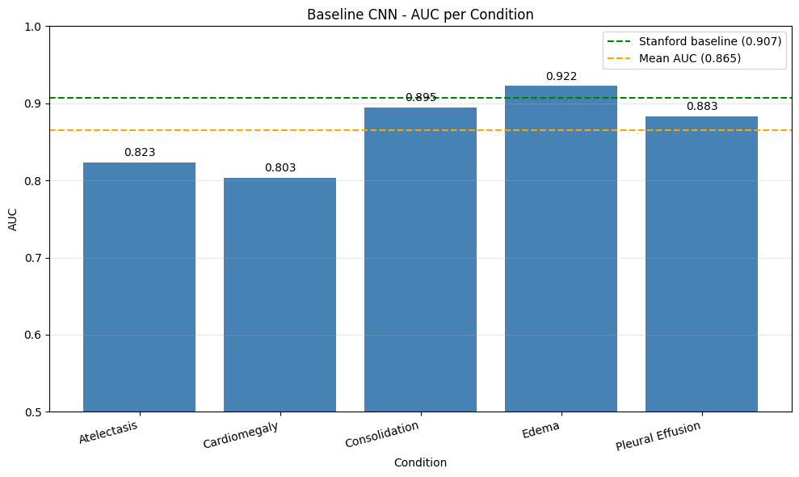
Figure 8: Baseline CNN AUC per condition
When evaluating performance at a fixed threshold of 0.5, the model showed high precision but consistently low recall across several conditions, as illustrated by Figure 9.
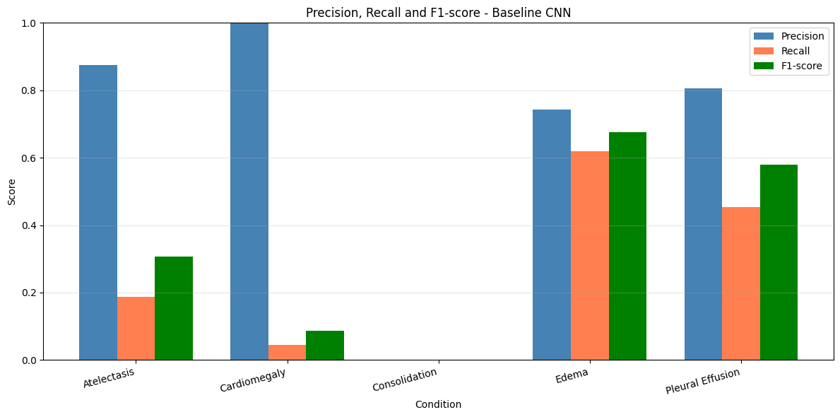
Figure 9: Precision, Recall and F1-score in baseline CNN
This resulted in low F1-scores, particularly for Consolidation, where the model failed to predict any positive cases, leading to a F1-score of 0. This could indicate that the model is overly conservative in predicting positive findings, likely due to class imbalance in the dataset. After applying threshold tuning, performance improved substantially across all conditions, as presented in Figure 10.
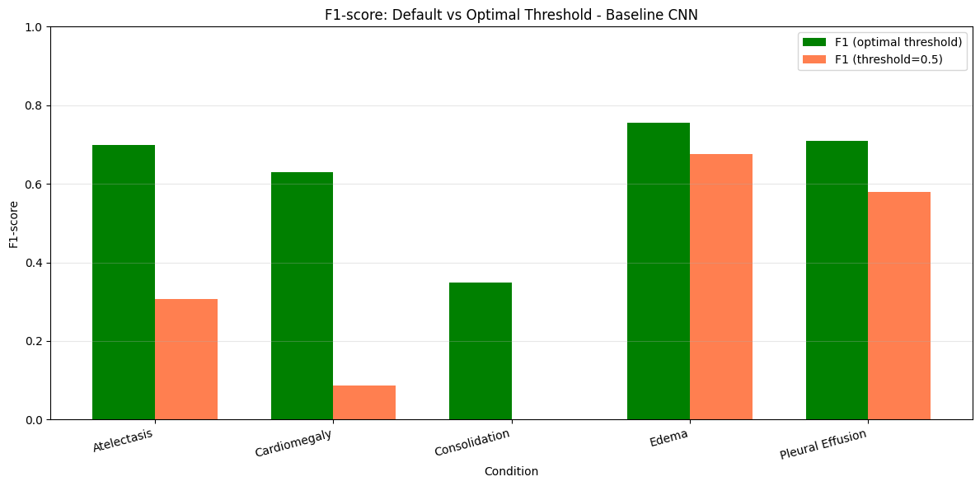
Figure 10: F1-score in default vs. optimal threshold in baseline CNN
These results show that choosing the right threshold is important when working with imbalanced datasets. The default threshold of 0.5 is not always a good choice, since it does not take into account that some conditions are much rarer than others, or that the model may assign lower probabilities to certain classes. In this project, this led to very low recall for some conditions, and even a complete failure to detect Consolidation, even though the AUROC scores were relatively high. This happens because many true positive cases get predicted with probabilities below 0.5, and are therefore classified as negative.
By lowering and tuning the threshold for each condition, more of these cases are correctly classified as positive, which increases recall. This can lead to more false positives and slightly lower precision, but overall the balance between precision and recall improves, as seen in the higher F1-scores. This effect is especially clear for the less common conditions, where even small changes in the threshold can make a big difference.
Overall, this shows that model performance is not only about how well the model learns, but also about how we turn its predictions into decisions. In practice, threshold tuning should be an important part of the evaluation, especially in medical settings where missing a condition can be more serious than raising a false alarm.

4.1.2 Transfer learning performance
Plotting AUROC and loss for training and validation with the DenseNet121 transfer learning model gives us Figure 11.
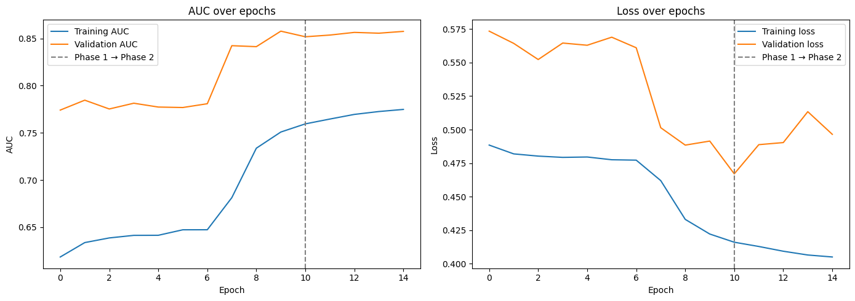
Figure 11: AUC and loss over epochs for DenseNet121

This model achieved a mean AUROC of 0.8571 on the validation set. Per-condition performance can be seen in Figure 12.

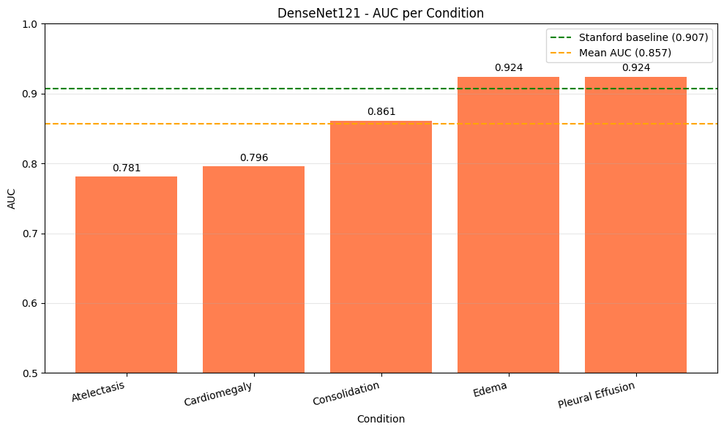
Figure 12: DenseNet121 AUC per condition
Looking at the precision, recall and F1-scores of the DensetNet121-model with the default classification threshold of 0.5, as presented in Figure 13, we observe that again the default threshold is suboptimal.
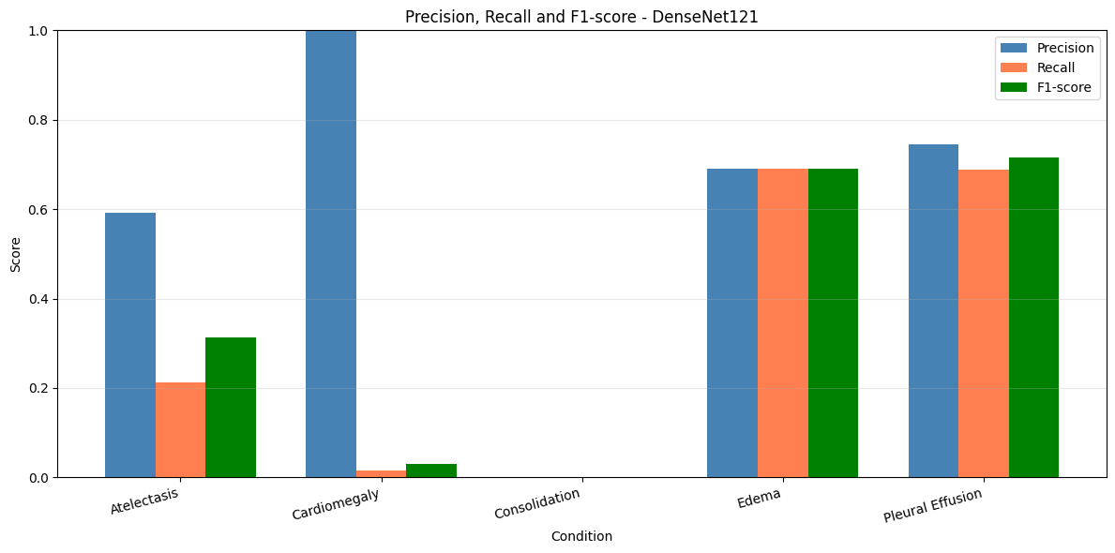
Figure 13: Precision, Recall and F1-score in DenseNet121
By selecting thresholds that maximize the F1-score per condition, performance improves substantially, particularly for conditions with low recall at the default threshold. For example, Cardiomegaly improves from an F1-score of 0.0299 at threshold 0.5 to 0.5556 at a threshold of 0.10, while Consolidation increases from 0.0000 to 0.3830 using the same lower threshold. These results indicate that the model tends to produce conservative probability estimates, leading to under-detection when using a fixed threshold. Overall, threshold tuning significantly improves the balance between precision and recall, as illustrated by Figure 14.
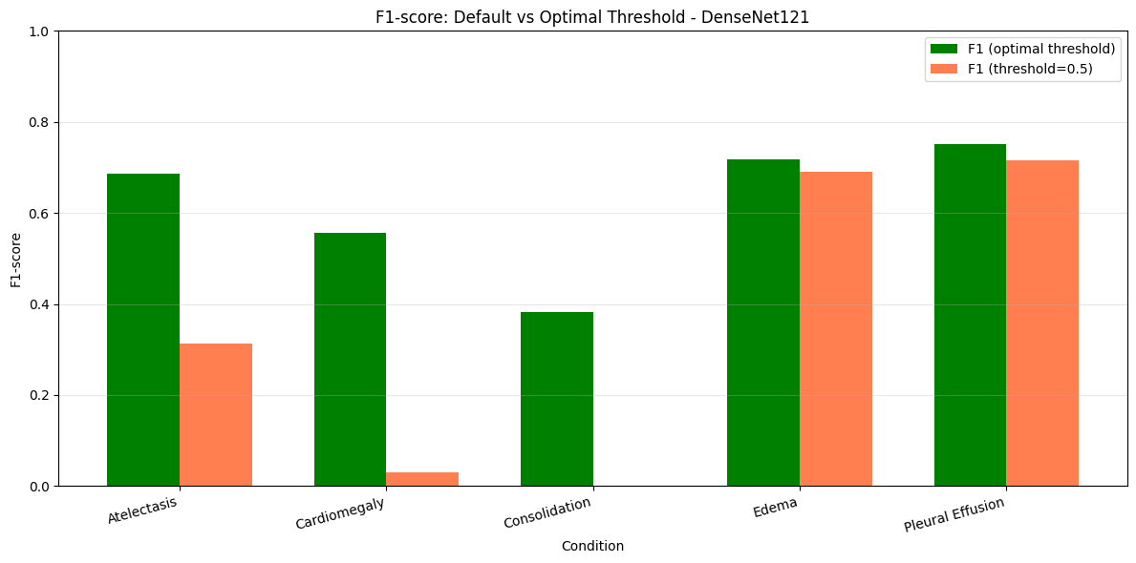
Figure 14: F1-score in default vs. optimal threshold in DensetNet121

Contrary to expectations, the transfer learning model did not outperform the baseline CNN. While it achieved strong results for certain conditions such as Edema and Pleural Effusion, overall performance was slightly lower.

4.1.3 Summary comparison
The results show that the baseline CNN achieves a slightly higher mean AUC than DenseNet121. However, this metric evaluates performance across all possible classification thresholds and does not reflect behaviour at a fixed decision threshold. At the default threshold of 0.5, the baseline CNN produces very few positive predictions, which can be seen in its high precision but low recall, indicating that it makes conservative predictions and misses many true positives. In contract, DenseNet121 shows a more balanced trade-off between precision and recall, leading to higher F1-scores. This suggests that while the baseline CNN ranks predictions slightly better overall, DenseNet121 is perhaps more desirable in a medical setting where missing a diagnosis can have serious consequences.
Table 1: Summary of performance metrics
Model | Mean AUC | Precision | Recall | F1-Score
Baseline CNN | 0.8653 | 0.6847 | 0.2609 | 0.3300
DenseNet121 | 0.8571 | 0.6058 | 0.3212 | 0.3499

4.2 Comparison with existing solutions
The models were compared against the CheXpert baseline reported by Irvin et al., which achieves a mean AUROC of 0.907 using an ensemble of models [9]. This comparison is presented in Figure 15.

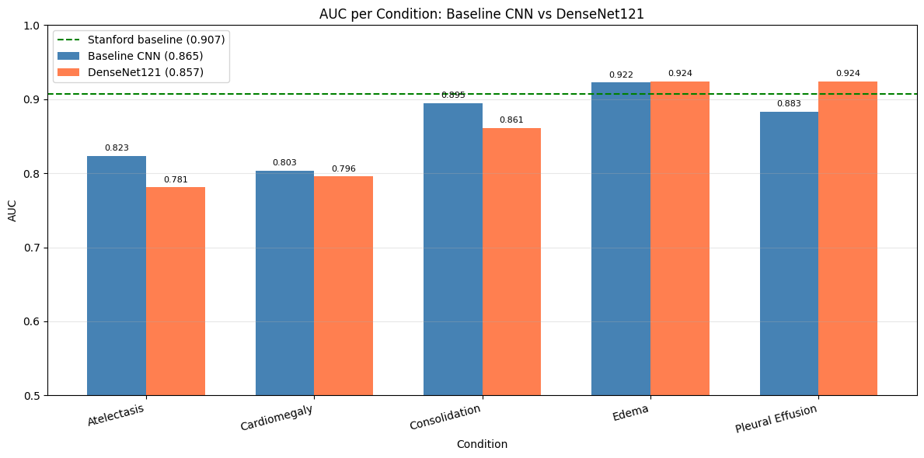
Figure 15: AUC per condition comparison
Both our models perform below the state-of-the-art baseline, which is expected given that the CheXpert model uses ensemble methods and extensive optimization, as well as our models using a smaller subsampled dataset.

4.3 Interpretation techniques
To complement the quantitative evaluation metrics, interpretability techniques were applied to better understand how the model makes predictions. To do this, we used Grad-CAM (Gradient-weighted Class Activation Mapping) to visualize the regions of the chest X-ray images that contributed most to the model’s predictions. Following Chollet & Watson in chapter 10 and Selvaraju et al., Grad-CAM generates heatmaps by computing the gradient of a target class with respect to the feature maps of the last convolutional layer [10, 11]. These gradients are used to weight the feature maps, producing a spatial map that highlights the most relevant regions for a given prediction.
The Grad-CAM analysis was performed using the best-performing model, which was the baseline CNN. For each of the five conditions, representative validation images were selected and visualized alongside their corresponding heatmaps and superimposed outputs, as seen in Figure 16.
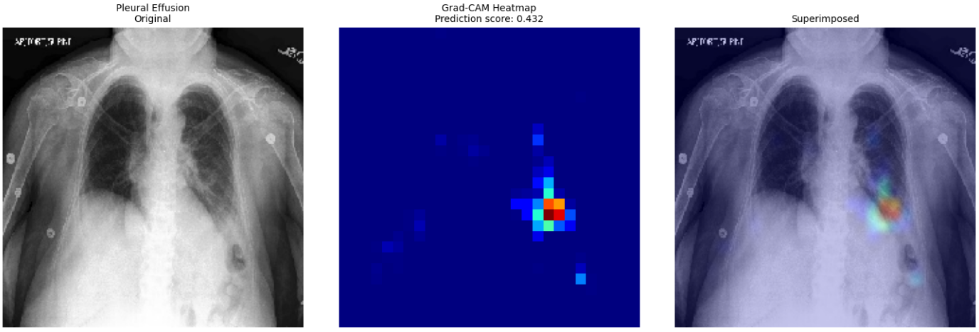
Figure 16: Grad-CAM Heatmap of Correctly Predicted Pleural Effusion
The results showed that for certain conditions, such as Pleural Effusion and Edema, the model focused on clinically plausible regions, particularly the lower lungs and lung tissue where fluid accumulation is expected. This aligns with medical knowledge and suggests that the model has learned meaningful representations.
However, for other conditions such as Cardiomegaly and Consolidation, the model sometimes focused on anatomically irrelevant regions or showed diffuse activation patterns. This is consistent with the lower AUROC scores observed for these conditions and could indicate that the model struggles to learn reliable features for them.
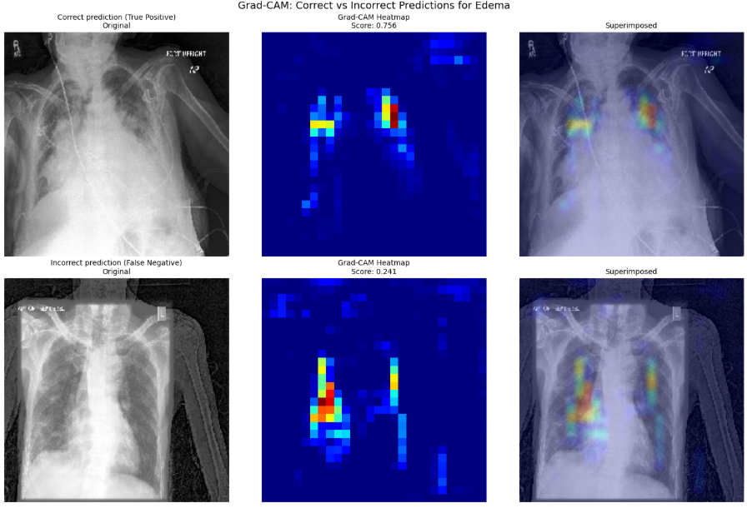
Figure 17: Grad-CAM Heatmap for Edema

Additionally, Grad-CAM was used to compare correct and incorrect predictions, as seen in Figure 17. For example, in the case of Edema, true positive predictions showed activation in relevant lung regions, whereas false negatives showed weaker or misplaced activation. This suggests that misclassifications may occur when the model fails to detect subtle patterns.
It is important to note that this evaluation of interpretability is qualitative and subjective. Ideally, clinical experts would assess whether the highlighted regions are medically meaningful. Within the scope of this project, Grad-CAM serves as a useful tool for gaining insight into model behaviour, but it does not provide a formal metric for interpretability, as discussed in chapter 1 of this report.

4.4 Model utilization and limitations
Although the DenseNet121 architecture is powerful, the results suggest that its full potential was not fully exploited in this project. There are several possible reasons.
First, the models were trained on a relatively small validation set, which may not provide a reliable estimate of generalization performance.
Second, the class imbalance in the dataset significantly impacts performance. This is evident from the low recall and F1-scores for several conditions, particularly Consolidation.
Third, it could be due to limited hyperparameter tuning, insufficient fine-tuning depth, and a lack of data augmentation and regularization strategies.

5 Deployment
This project was deployed as a temporary web application only for the benefit of the course assessor. There are some strong ethical concerns with deploying software such as this as a web application and asking users to upload their radiographs. We worry that users would blindly accept the results of the classification model instead of seeking the opinion of a health care professional. In addition to this, we did not wish to spend time focusing on web security to ensure that malicious users do not gain access to the private radiographs of other users. Thus, this application would preferably be deployed as local software to be used in a clinical setting.
The chosen framework (TensorFlow/Keras) provides strong support for deployment, as models can be easily serialized and loaded for inference.
For a deployed system in a clinical setting, continuous monitoring and maintenance would be essential. Key aspects especially include performance monitoring by tracking prediction quality over time to detect model drift or degradation, and ensuring that incoming radiographs are similar in distribution to the training data. Logging should also be implemented, by recording predictions and model outputs to ensure traceability and support clinical validation.

To improve user experience, there are some extensions which could be implemented.
- Flagging cases that should require human review in the case of low-confidence predictions.
- The ability to compare predictions across multiple images in clinical settings, e.g., previous vs. current scan.
- Support batch uploads of X-rays.
- Introduce a mechanism where medical personnel can flag incorrect predictions and provide corrections, which could be used to enable future model retraining.

6 Conclusion
The goal of this project was to develop a deep learning model for multi-label classification of chest X-ray images, while also exploring interpretability techniques.
The results show that deep learning provides a viable approach to this problem. The baseline CNN achieved a mean AUROC of 0.8653, while the DenseNet121 transfer learning model achieved 0.8571. Both models performed reasonably well, but neither reached the performance of the CheXpert baseline (0.907), which could be expected given the use of ensembles and more extensive optimization in their work [9].
In hindsight, the chosen metrics were appropriate for evaluating model performance. AUROC gave us the means for direct comparison with the CheXpert baseline and is well-suited for imbalanced multi-label classification. However, additional metrics such as precision, recall, and F1-score revealed important weaknesses that AUROC alone does not capture. Specifically, both models exhibited low recall for several conditions, and completely failed to detect Consolidation at the default threshold, resulting in precision, recall, and F1-score of 0. This highlights the importance of combining threshold-independent metrics such as AUROC with threshold-dependent metrics when evaluating models in clinical settings.
Deep learning proved to be a viable solution to this task; however the project also highlights several challenges, such as sensitivity to class imbalance, difficulty in interpreting model decisions, and dependence on large amounts of high-quality data. The fact that both models failed to detect Consolidation at the default classification threshold likely indicates severe class imbalance or insufficient positive samples for this condition in the validation set. It may also suggest that the visual features associated with Consolidation are more difficult to learn, or that the models are biased towards more frequent conditions.
There are some improvements that could be explored in future work. If we look at the CheXNet model, we see that we could benefit from more extensive hyperparameter tuning, implementation of ensemble methods, and perhaps more advanced data augmentation strategies [9]. Techniques such as class weighting could help address class imbalance. Finally, instead of using the subsampled dataset provided by the Kaggle user Ashery, we could have used the complete dataset presented by Stanford ML Group and evaluated the models on a larger and more representative validation set [8] [9].

References

[1] | J. S. Klein and M. L. Rosado-de-Christenson, “A Systematic Approach to Chest Radiographic Analysis,” in Diseases of the Chest, Breast, Heart and Vessels 2019-2022, Cham, Springer, 2019, pp. 1-16.
[2] | K. Piper, S. Cox, A. Paterson, A. Thomas, N. Jeyagopal and N. Woznitza, “Chest reporting by radiographers: Findings of an accredited postgraduate programme,” Radiography, vol. 20, no. 2, pp. 94-99, May 2014.
[3] | R. G. Dreyer, C. M. van der Merwe, M. A. Nicolaou and G. A. Richards, “Assessing and comparing chest radiograph interpretation in the Department of Internal Medicine at the University of the Witwatersrand medical schhol, according to seniority,” African Journal of Thoracic and Critical Care Medicine, pp. 12-17, 2023.
[4] | L. Rundo and C. Militello, “Image biomarkers and explainable AI: handcrafted features versus deep learned features,” European Radiology Experimental, vol. 8, 2024.
[5] | A. A. Nasser and M. A. Akhloufi, “A Review of Recent Advances in Deep Learning Models for Chest Disease Detection Using Radiography,” Diagnostics, vol. 13, no. 1, 2023.
[6] | A. Hosny, H. J. Aerts and R. H. Mak, “Handcrafted versus deep learning radiomics for prediction of cancer therapy response,” The Lancet Digital Health, vol. 1, no. 3, pp. 106-107, 2019.
[7] | P. Rajpurkar, J. Irvin, K. Zhu, B. Yang, H. Mehta, T. Duan, D. Ding, A. Bagul, C. Langlotz, K. Shpanskaya, M. P. Lungren and A. Y. Ng, “CheXNet: Radiologist-Level Pneumonia Detection on Chest X-Rays with Deep Learning,” arXiv, 2017.
[8] | Ashery, “CheXpert-v1.0-small [Data set],” [Online]. Available: https://www.kaggle.com/datasets/ashery/chexpert.
[9] | J. Irvin, P. Rajpurkar, M. Ko, Y. Yu, S. Ciurea-Ilcus, C. Chute, H. Marklund, B. Haghgoo, R. Ball, K. Shpanskaya, J. Seekins, D. A. Mong, S. S. Halabi, J. K. Sandberg, R. Jones, D. B. Larson, C. P. Langlotz, B. N. Patel, M. P. Lungren and A. Y. Ng, “CheXpert: A Large Chest Radiograph Dataset with Uncertainty Labels and Expert Comparison,” 21 January 2019. [Online]. Available: https://arxiv.org/abs/1901.07031. [Accessed 2026].
[10] | F. Chollet and M. Watson, Deep Learning with Python, 3rd ed., Manning Publications, 2025.
[11] | R. R. Selvaraju, M. Cogswell, A. Das, R. Vedantam, D. Parikh and D. Batra, “Grad-CAM: Visual Explanations from Deep Networks via Gradient-Based Localization,” International Journal of Computer Vision, vol. 128, pp. 336-359, 2019.
[12] | S. Brealey, A. Scally, S. Hahn, N. Thomas, C. Godfrey and A. Coomarasamy, “Accuracy of radiographer plain radiograph reporting in clinical practice: a meta-analysis,” Clinical Radiology, vol. 60, no. 2, pp. 232-241, 2005.
[13] | P. J. Robinson, D. Wilson, A. Coral, A. Murphy and P. Verow, “Variation between experienced observers in the interpretation of accident and emergency radiographs,” British Journal of Radiology, vol. 72, no. 856, pp. 323-330, 1999.
[14] | R. Yamashita, M. Nishio, R. K. G. Do and K. Togashi, “Convolutional neural networks: an overview and application in radiology,” Insights into Imaging, vol. 9, pp. 611-629, 2018.

Appendix: Declaration of use of Artificial Intelligence
During the process of writing this report, artificial intelligence has been used. To ensure that the report was as comprehensive as possible, the project guidelines have been fed to GPT UiO, along with a PDF of our report in different iterations. GPT UiO has then been prompted to give us constructive feedback, and to report if we are missing content from our report that would be necessary to satisfy the project guidelines published on Canvas.

